BE Semiconductor (BESI)
Category: Equipment
Est. Price Per Unit: ~$2M per machine

What They Do

Product 101 and Where They Fit into the AI Stack
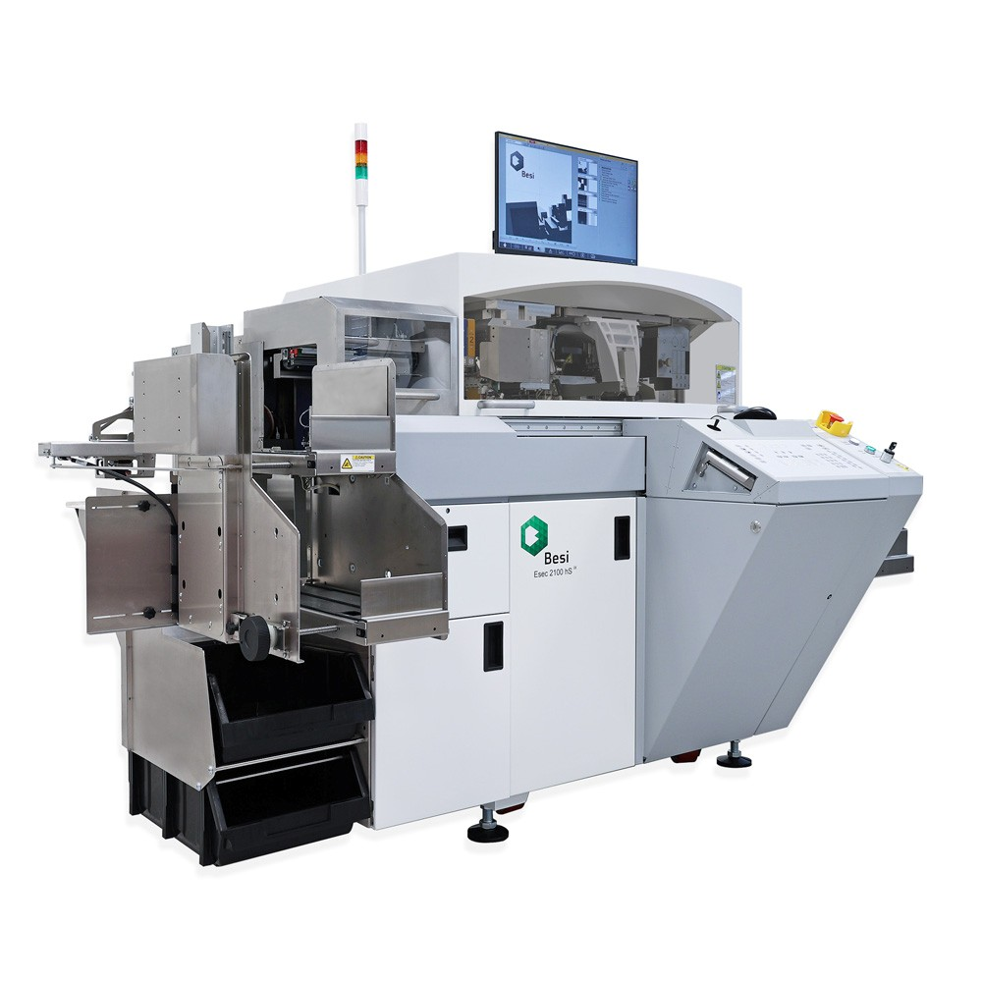
BESI is hyper focused on Die attach technology (80% of revenue) - specifically Die-to-wafer. Attach methods are required
to stick (solder) the chips on the board, or onto other chips.
The attach methods are evolving:
and growth is slow.
Standard die attach (majority of OSATs): soldering or epoxy. BESI plays here as a cash cow, but differentiation is low,
TCB (Thermocompression Bonding): Currently growing; used for current HBM and CoWoS technology to stack chips on top of each other (an H100 HBM chip has 8+ stacks glued together). The TCB method still uses heat to stick components together. This space is competitive with ASMPT and K&S.
Hybrid Bonding: The main bet with BESI. Makes the dies so flat that the atoms stick together without heat (like how a gecko climbs with static). This technology enables chip on chip stacking required for CoWoS SoIC (System on Integrated Chips). The method can improve bandwidth, reducing the memory wall.
However, this is difficult technology, and a single particle of dust can ruin a whole chip. The rollout of hybrid bonding has been delayed, but the Founder-CEO continues to bet that this is the future.
If Hybrid Bonding becomes standardised, BESI will enjoy a near monopoly on the space.

Alignment with Overall Thesis
The memory wall will continue, and bandwidth of the HBM stacks will become important. If BESI can prove that hybrid bonding can be productionised, then they will sell to every fab and memory IDM shell to power the AI demand.
This also creates tailwinds for inspection companies.

Business Model, Customers
Est. $2M per machine.

Comments on Team
Founder led. CEO founded company in 1995 and has remained CEO since.

Early View of Moat Hypothesis
Definitive leader in hybrid bonding technology with a hyper focused founder bet.

Why They're Interesting, and Why Now
JEDEC
(a semiconductor standards committee) had planned to require maximum height limits for HBM. Such limits, with
the current stacks, require a shift to hybrid bonding to reduce height.
However, this standard has been
delayed about 2 years
.
Nevertheless, this feels like a
near term call option
on advancing the AI stack forward.

Key Risks
Hybrid Bonding doesn't take off and BESI is left to compete in the more competitive TCB space.

Select Financial Graphs

R1: Total Revenue & YoY Growth
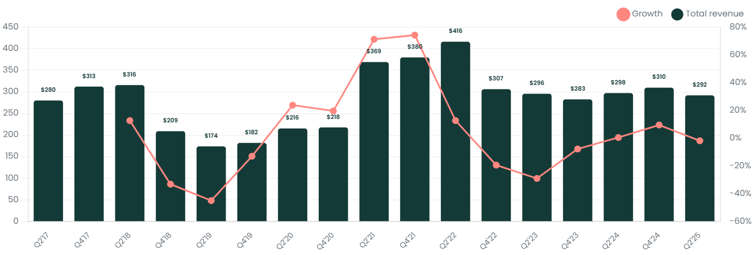

I1: Inventory Turns
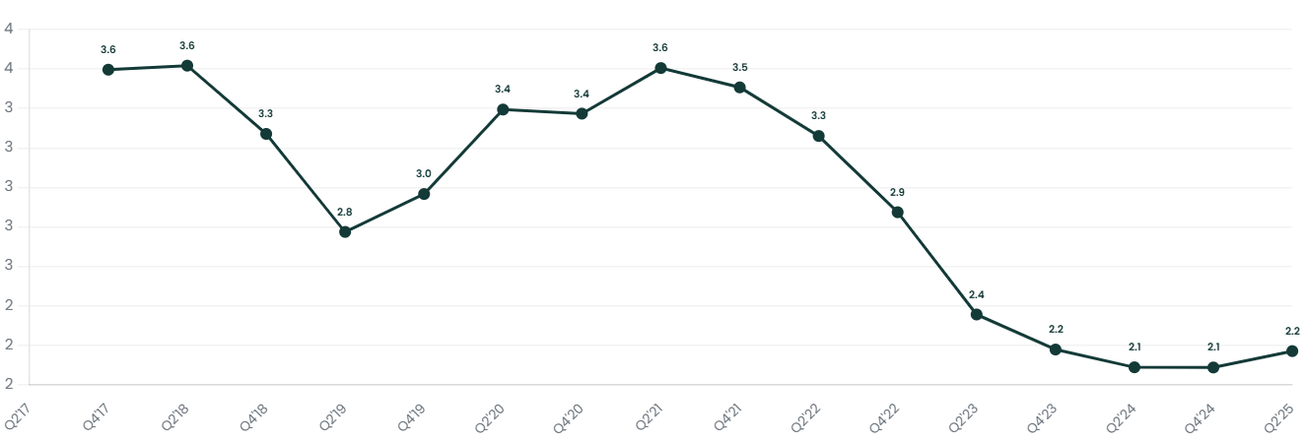

P4: EBIT Margin
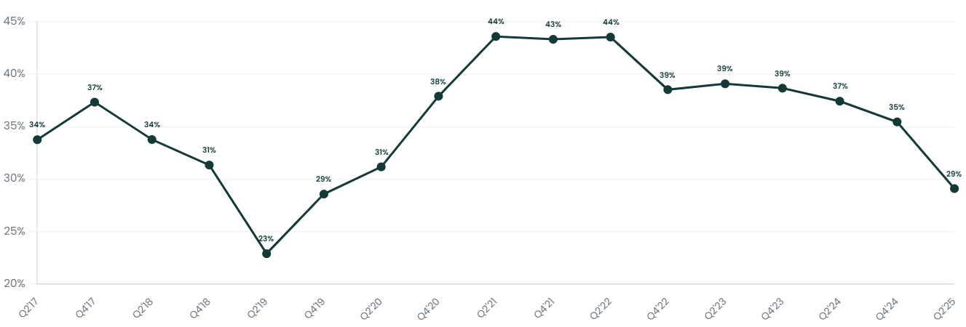

S3: IDM Orders as % of Revenue
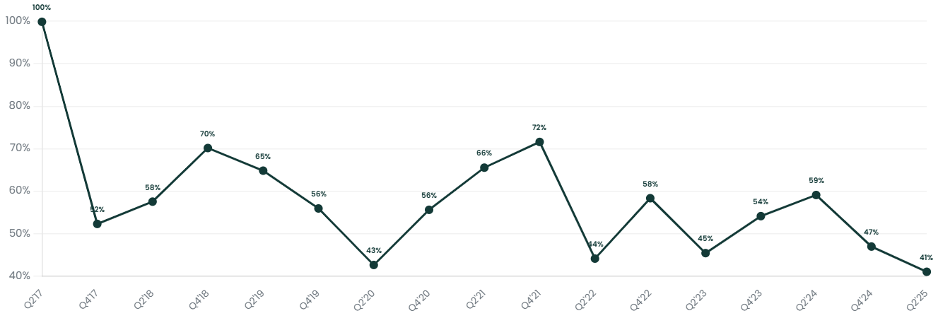

S4: Die Attach as % of Revenue
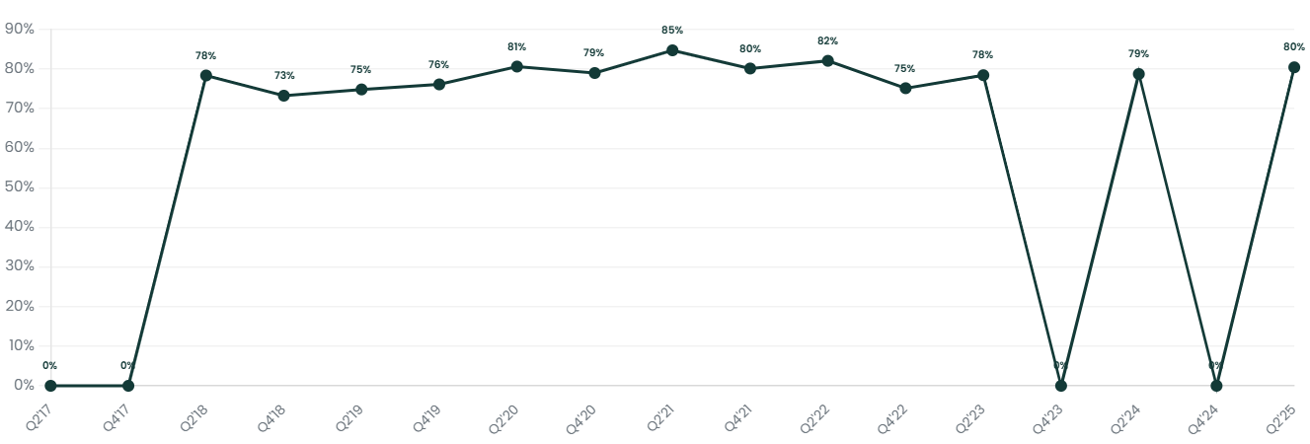

V1: EV/Sales NTM
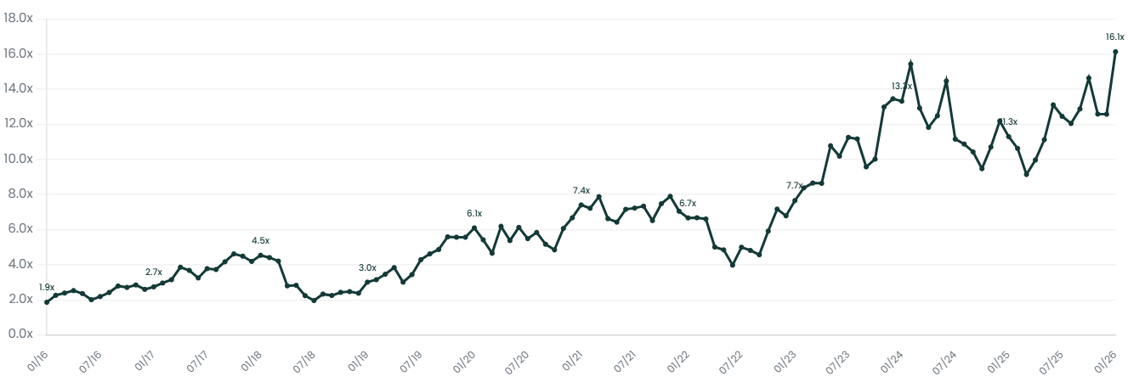

Patent Analysis

Bonding Equipment: BESI vs ASMPT
BESI patent citations jumped 2021-22, suggesting increasing relevance of their IP as hybrid bonding approaches production.
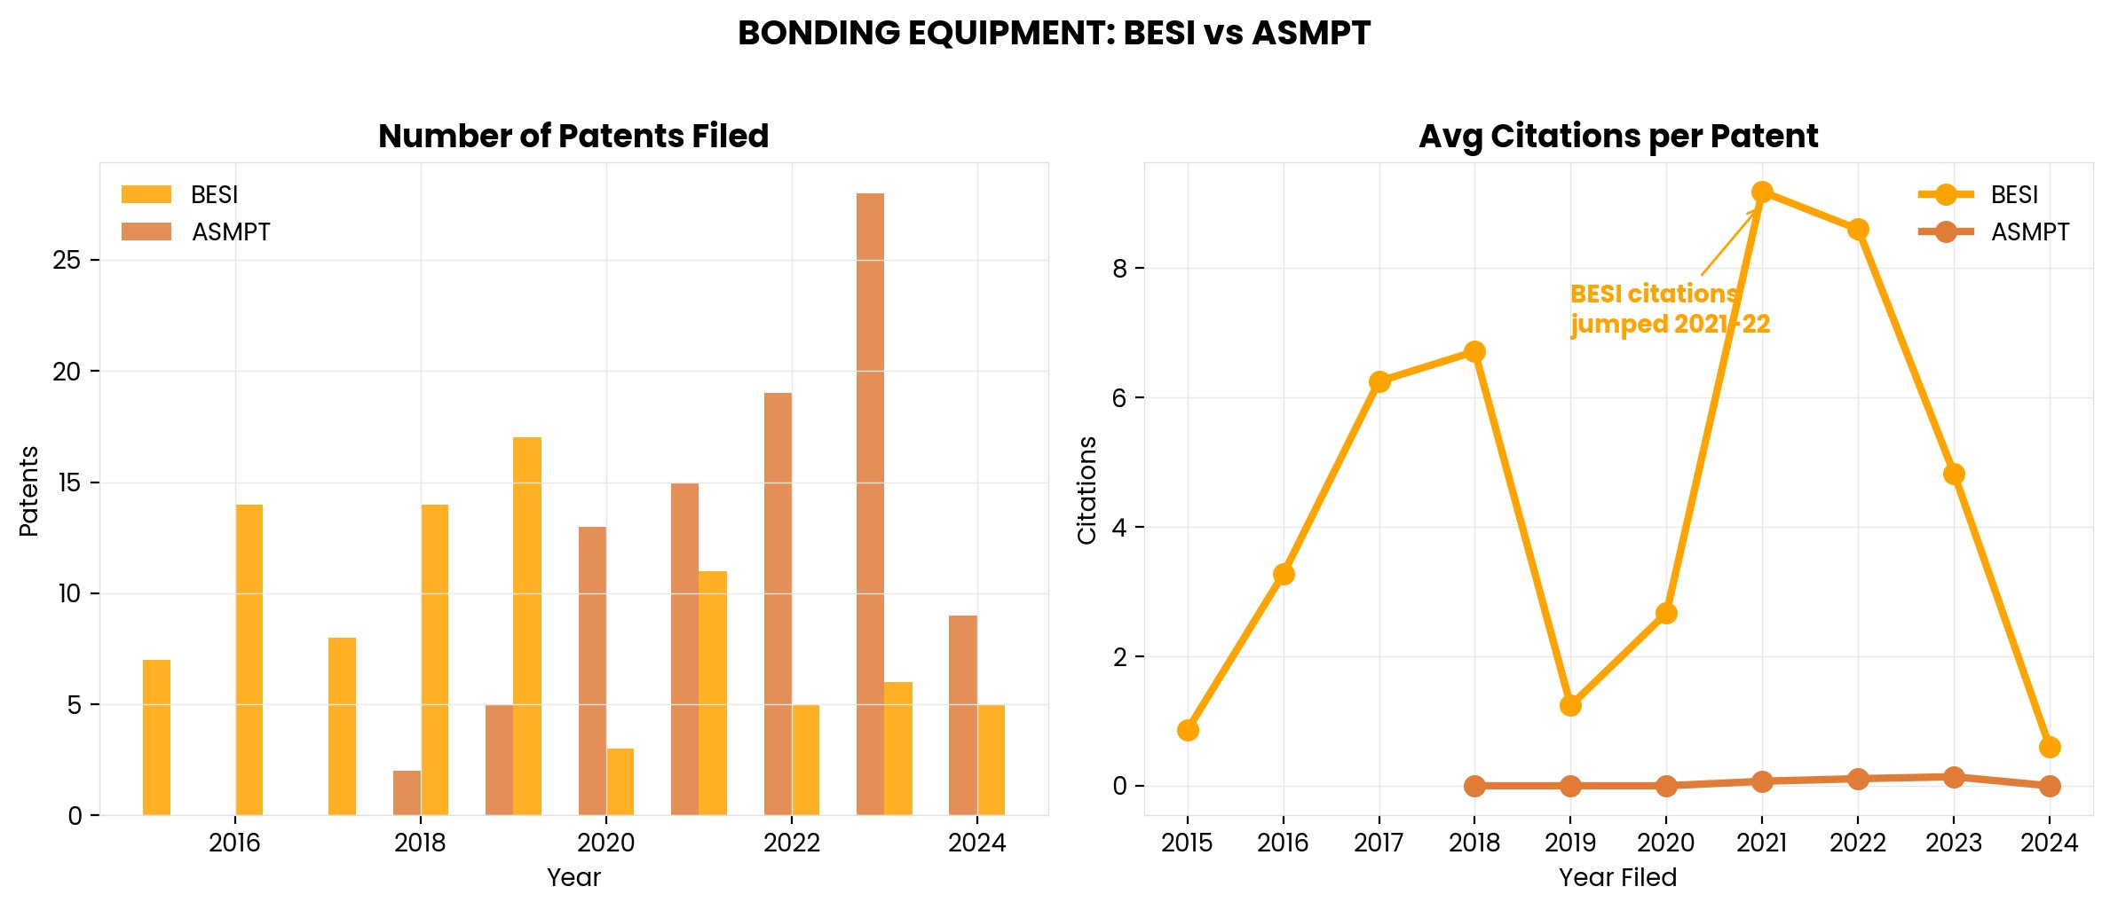
Who Is Citing BESI Patents?
17.2% of citations come from foundries/IDMs (highest of all companies analysed). Micron is the largest source—suggests strong memory packaging relevance.
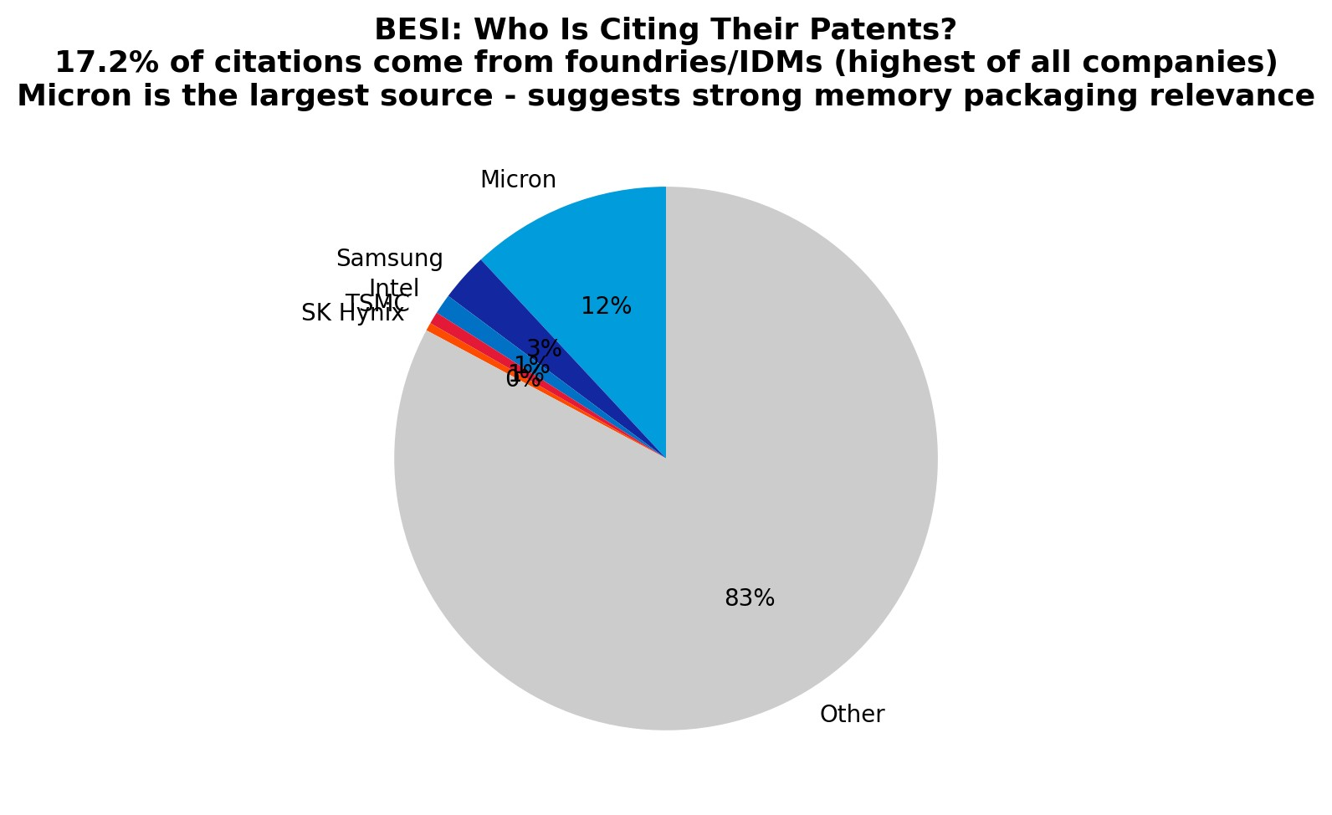

Interesting Topics to Read
Hybrid Bonding vs. TCB
JEDEC HBM height standards

